How to Work From Home Comfortably: Tips from the Experts
As you continue to become more accustomed to working from home, it is important to learn the proper ways to stay pain-free and productive from your home workspace. Whether that means setting aside an area to create a new home office, buying an ergonomic chair or desk for your living room workspace, or simply taking more breaks and focusing on yourself. There are so many tips and tricks to make working from home more comfortable. Which is why we asked experts from Miami, FL to Seattle, WA to share their advice about the most effective ways to keep your body healthy and pain-free while working from home.
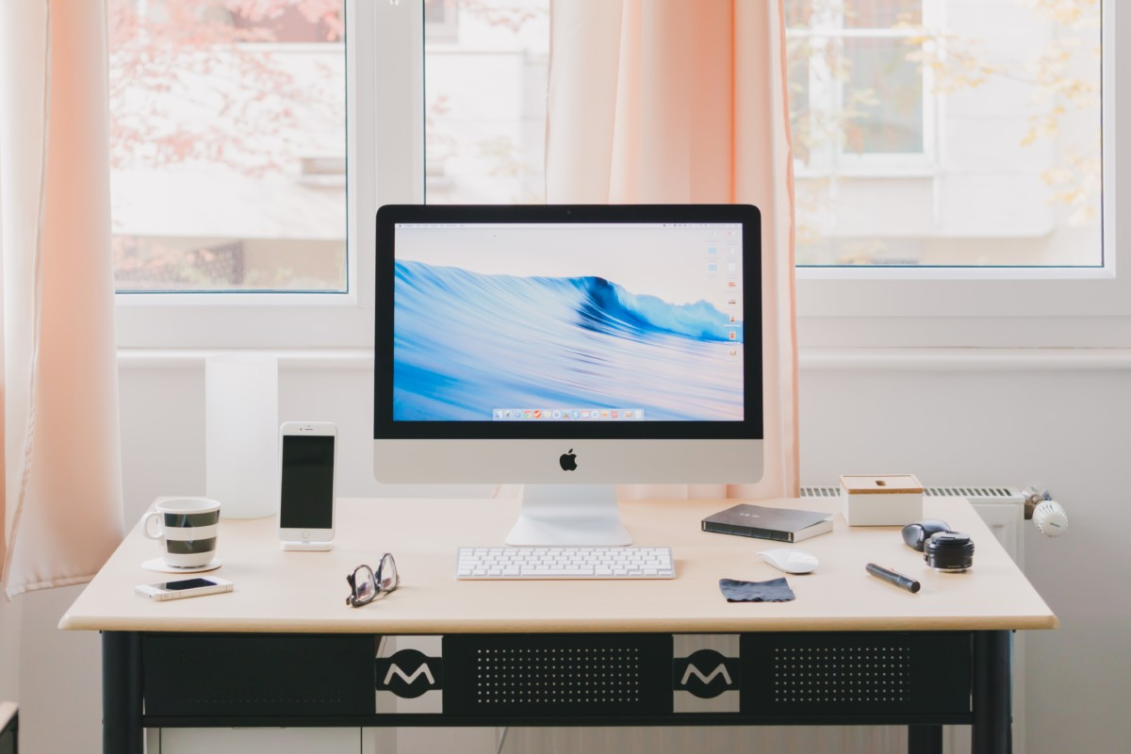

Create a functional workspace
Working from home can be an enjoyable experience if you follow these tips. Create a functional space or room dedicated to work, make sure to block out time to be most productive and make a list each night of things that are a priority to get done during your work time the next day. In addition, take ergonomics seriously as prolonged poor posture can cause serious issues in the spine. Make sure you’re not laying down on your bed or the couch for prolonged periods of time. -New Leaf Chiropractic
Ergonomics matter. If you are still working on the couch or at your kitchen counter, it is time to stop and set up a workstation that doesn't put additional strain and tension on your muscles. A good chair and desk allow your body and muscles to work comfortably and safely. -Massage & Bloggywork

Take a 5-minute break every hour
Make sure your work station is set up where the monitor is at or above eye level to avoid causing strain on the neck or back. Also, taking a 5-minute break or engaging in some hamstring stretches hourly will be crucial in pulling tension off of the lower back and hips. -Corrective Chiropractic

Keep your device at raised and at eye level
To keep from hunching over your laptop, raise your device on books or a box so the top of the monitor is eye level and use an external keyboard and mouse. Also, to help you sit up straighter-raise your hips so they are higher than your knees when you sit, which also takes the pressure off your low back (fold a towel to get the seat area high enough if necessary). Remember to stay hydrated and get up and move every 30-45 minutes! -Dr. Jane H. Baxley, Posture Vitality

Avoid eye strain
Don't forget to address eye strain with the 20/20/20 rule. Every 20 minutes, look at least 20 feet away from the computer for 20 seconds. This is best done out a window with natural light. -The Ergonomic Expert

Try a new movement or exercise every day
The most important thing when you are unable to set up an ergonomic workspace is giving yourself some variety - it's the spice of life and movement. If you spend a lot of time rounded (i.e. sitting), spend some time lying on your stomach or opening your posture. Don’t limit yourself to your chair or couch - try a new movement or exercise every day to test your limits! This ebook has some examples for you.” -Pat Carver, PT, DPT, Limitless Physical Therapy

Don’t sit in a static position for an extended period of time
Do not sit for more than 30 to 40 minutes without getting up and walking around (even briefly). A properly set up chair and workstation are very important, but the body is not designed for prolonged static positioning. Consider a workstation where you can stand part of the day and sit part of the day, your body will thank you for this. -Bill Hull, OrthoBethesda

Take care of your body and mind
Working from home requires taking care of your body and your mind; sitting correctly on an office chair or balance ball will help with posture and regular breaks, stretching and standing will help you physically. If you can, make a weekly visit to your spa for a relaxing massage. Take care of your mind and schedule phone calls to friends and family - it’s so important for mental health to stay connected! -Bali BISA

Focus on your alignment and posture
Consider your hips, chest, and head like a snowman and keep all three in good alignment. Be sure your feet are firmly on the ground or an elevated footrest and have everything reachable so your elbows stay close to your side, hands below elbows. Finally, remember humans must move to be healthy - be sure to get away from work and move your body every day! -Jean Massé, Advance Physical Therapy
It’s all about your attitude. Build on a good foundation by not sitting on your tailbone and hold your stomach in, all of the time. Of course, set up your station with good ergonomics in mind and If you practice sitting for the 24 minutes standing for 20 and moving for 12 rule you’ll often prevent most of those aches and pains and increase your productivity in the process. -Align1 Solutions

Meditate to reduce stress and boost productivity
A growing body of research now supports what many people have experienced firsthand; a brief 3-5 minute meditation practice helps boost creativity, supports nonjudgmental thinking, increases productivity, and lowers overall stress. With so many types of guided meditation available, we suggest exploring mindfulness techniques until you find what works for you. Calming the mind is a challenge for us all, so be kind to yourself and know that even a short 3-minute practice can have a huge impact on your day. -Body Techniques

Find ways to stand while working
Be creative to find ways to stand. You can place a laptop on an ironing board either on the floor, bed, countertop, or table depending on how tall you are.” -Solutions Northwest, Inc.

Focus on your breathing
I’d say most of the advice you’d get about feeling well while working from home is to stretch regularly. And, yes, you should be doing that! But, the stress of these times is not only physical; it’s emotional as well. Many of us are feeling overwhelmed, and as we move into the Autumn the qualities of lightness and dryness begin to affect us, making us feel ungrounded and anxious. Practicing alternate nostril breathing is very powerful and impactful, almost immediately. -Soma Spa

Try a series of neck rolls every hour
Sustained positions while working at home are bad for the body, and the neck/shoulders area is often the first to sound the alarm through tension and discomfort. Do your neck and head a favor by, every 30 minutes, step away from your screen and do a series of slow neck rolls - both clockwise and counter-clockwise. Kevin Bell, DPT at Kinetix Advanced Physical Therapy

Engage in proper ergonomics
Most people suffer from back, neck, and wrist injuries due to poor posture. We recommend setting up a proper ergonomic posture with your desk surface at your hand level (ninety degrees to shoulders), eye-level (directly looking at the top of the monitor), a wrist pad, and an ergonomic chair with proper back and neck support. With these simple steps, you can avoid most problems associated with improper ergonomics. -Star Ergonomics
Originally Published on Redfin

